Disaster Recovery Guide
for Business

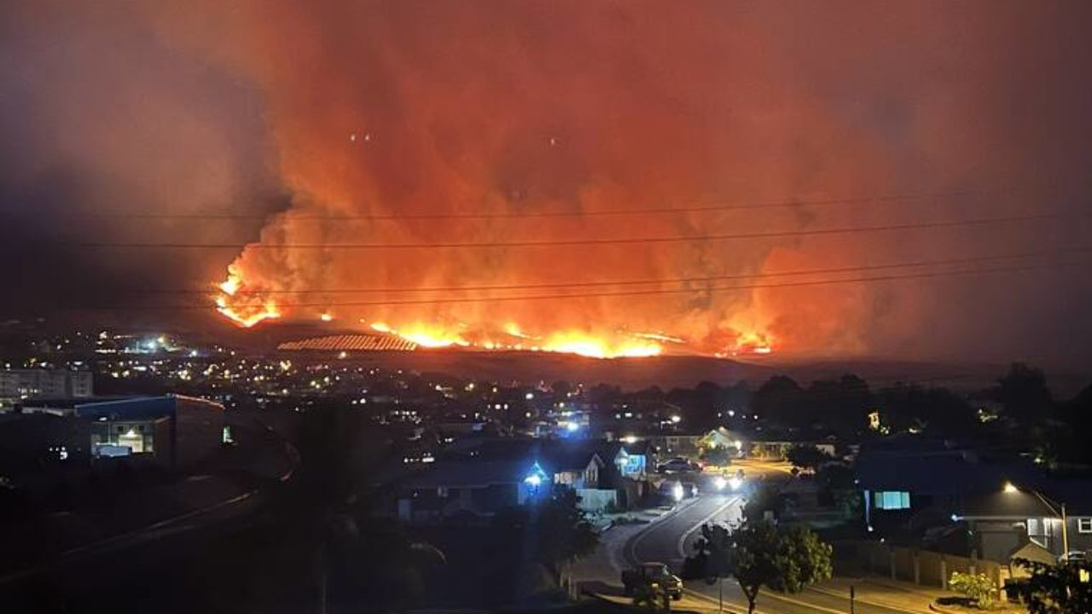
Presented By:

You may be in business for yourself – but you don’t have to be in business by yourself

Hawai‘i SBDC Disaster Recovery Guide for Business
Welcome to the Hawai‘i SBDC Disaster Recovery Guide for Business, adapted with permission from the Vermont SBDC.
It is designed as a working guide that will direct you through the steps as you consider how to proceed post-disaster.
We advise that you utilize the Guide, in conjunction with your local Hawai‘i SBDC Advisor, who is ready to help you walk through all of the steps. Or, if you choose not to work with an advisor, it is set up so you can do the steps without assistance.
We wish you well through this process.
— The Staff of Hawai‘i SBDC Network

Funded in part through a Cooperative Agreement with the U.S. Small Business Administration and their Portable Assistance Program. All opinions, conclusions, and/or recommendations expressed herein are those of the author(s) and do not necessarily reflect the views of the SBA.

©VtSBDC 2013 – Adapted
with permission by the Hawai‘i SBDC

Table of Contents

First Assessment – Personal 1
Instructions on how to use the rest of the Hawai‘i SBDC Disaster Recovery Guide for Business 3
Disaster Recovery Steps 5
First Assessment Post-disaster – Business 6
Preliminary Actions 7
What is the current financial position of your business? 9
Should you reopen your business? 10
What are your chances for success? 11
Recovery Plan 12
Funding the reopening of your business 13
Sources of Financing 14
Reopening Steps 15
Closing Comments 18

First Assessment – Personal
Answer the following questions using the charts below. You can also create action steps with dates due and who is responsible if you would like.
Safety
Question | Yes | No | Action and/or Comments | By whom | By when
Adequate clothing
Adequate food
Adequate housing
All employees accounted for
(Use the worksheet provided to create a full employee list if you do not have one.)
All employees safe

Registration – if required.
You will know the level of registration required only after a disaster has taken place. The state may ask you to call a number and let them know that your business has been affected so that they can continue to provide you with information.
If there is a federally declared disaster, there will be instructions coming from the federal authorities on what you need to do.
Question | Yes | No | Action and/or Comments | By whom | By when
Registered with state
Registered with federal
Business Insurance
Insurance Agent name: |  |  | Phone: |  | Email:
Question | Yes | No |  | Action and/or Comments |  | By whom | By when
Contacted insurance agent
Documented damage in a list
Took photos

Call your advisor back and they will outline the next steps:

Hawai‘i SBDC Advisor name: | Phone: | Email:
Appointment
We strongly suggest that you make a follow-up appointment when you call your advisor for the next steps.
Date: | Time: | Location:

NOTES:
________________________________________________________________________________________________________________________________________________________________________________________________________________________________________________________________________________________________________________________________________________
Instructions on how to use the rest of the Hawai‘i SBDC Disaster Recovery Guide for Business:
- We suggest that you get an accordion file with a handle (or some kind of folder that can be closed and easily carried) and gather all your information in one place. You will be referring to this information on a daily basis, and it will need to be mobile unless your facility is useable. And even if you can get into your office, you will want all of the following information in one place that is easily accessible.

- The guide is designed to help you gather information that you need, make assessments, answer questions, and make the best business decision for you and your company. It is designed as a series of steps.
  - We have provided an overview, in the form of a flow chart, of the steps that need to be taken. (See page 5.)

- The guide is also designed to be your worksheet and has checklists and places to record actions that need to be taken.

- Take notes as you work through the Guide.

- If something has a star that means there are additional sheets that will make it easier to gather and organize the information that you will need.

- We will help you maneuver through the following assessments and action steps by keeping in touch with you in the method most helpful to you (phone, email, and in-person check-ins).
Take the time to answer the questions carefully and give yourself plenty of time and space to make your decisions.

After a disaster the most typical reaction is to get back to normal as quickly as you can. Studies and data show us that the “old” normal is gone and a “new” normal needs to be put into place. Give yourself time to get acclimated.

Businesses have told us that they felt the pressure of all the well-meaning folks around them who want the same thing. But this is your business and your life, and you need to make the best possible decision for yourself and for your family—and that takes time.

As hard as it will feel to complete this workbook, businesses that worked through these steps tell us that it was well worth it and that their overall recovery was more successful.

We are here to help you.

- There are many steps to disaster recovery, and it is important to determine if you can take these steps alone. Please know that most people need help during this process. So who, besides us, can help you? Make a list of these people (with their contact info) below so you have it in this file:
Name: | Phone: | Email:
NOTES:
________________________________________________________________________________________________________________________________________________________________________________________________________________________________________________________________________________________________________________________________________________________________________________________________________________________________________________________________________________________________________________________
____________________________________________________________________________________

Disaster Recovery Steps
How to fund the reopening
Create a Closing Checklist with your SBDC Advisor
NO
No
REOPEN ?
REOPEN
Securing sources of financing
Create a recovery plan
What are your chances for success
YES
Current financial position of company

DO ALL PRELIMINARY ACTIONS

First Assessment -- BUSINESS
First Assessment -- PERSONAL

No

First Assessment Post-disaster – Business
The most immediate task after addressing the personal and safety issues is to do a quick evaluation of the situation at the business.
If you have a disaster recovery plan, access it and begin to implement. If not, use the questions below to inform your next steps.
Question | Yes | No | Action and/or Comments | By whom | By when
Facility operational?
Reopen without significant repairs?
Inventory damaged or recoverable or need to be replaced?
Supplies damaged or recoverable or need to be replaced?
Equipment damaged or recoverable or needs to be replaced?
Does the building need to be secured against theft/vandalism?
Does the business have a web site that is still active?
Should it be shut down?
- Should a message be placed on it telling clients what has happened and to stay tuned?
Losing money daily?
How much?
Use the Quick Cash Loss Calculation sheet.
How much do you need to live on? Use Personal Budget Sheet.
Access to monies to pay personal bills?
Note: If this is a federally declared disaster, as the owner you are also eligible for DUA (Disaster Unemployment Assistance). Ask your Hawai‘i SBDC advisor for instructions.

Preliminary Actions:
This is the next series of to-do’s that you need to consider and take care of. Each step of this process will build on the last.
Question | Yes | No | Action and/or Comments | By whom | By when
Preliminary damage assessment to insurance company.
Insurance company has given you payment amount; and date you can expect to receive it.
List and contact your key stakeholders (include key customers, suppliers & lenders/investors).
Use Key Stakeholder sheet.
Have contacted local, state and federal government agencies.
Created an accounts payable list by date due – what bills do you owe and when are they due?
Use Aged AP sheet if you don’t have one from QuickBooks or other accounting source.
Contact vendors about payment schedules. (Ask for best deal.)
Make decisions about staff in immediate future. Layoff? Refer to unemployment? DUA? Keep some?
Use Employee Action List
Postpone purchasing supplies/inventory?
Cancel orders that you have made?
Use Vendor Orders to Cancel List

Question | Yes | No | Action and/or Comments | By whom | By when
Customer orders? Can you fulfill them? Have they been lost?
Use Customer Orders Action List

Are there standard orders that you fulfill that you need to talk to specific clients about?
Access to your computers?
Working? Is data intact?
If computer is not working, do you have back-up that you can download onto another machine?
Check in on your website again and make sure that orders have been stopped if necessary.
- If you can still fulfill orders, make sure clients know the situation and that there may still be some delays.
If you have computer access, consider posting on Facebook and other social media.
- If there are ways that your customers can help, this is a way to keep in touch with them.

NOTES:
____________________________________________________________________________________
____________________________________________________________________________________
____________________________________________________________________________________
____________________________________________________________________________________

What is the current financial position of your business?
This process is extremely important in helping you decide your next steps. If you need assistance with this section, it is vital that you get it. Your accountant is the most logical place to start. Your bankers will also be willing to help, as will your Hawai‘i SBDC advisor.
Question | Yes | No | Action and/or Comments | By whom | By when
Have all the business financial records?
Have your last 3 years of tax returns?
No available financial information: Use Reconstruction Financial Data sheet.
What is your insurance agent telling you about your policy and what will be covered and what won’t be covered? Make a list.
Determine available cash.
Use Aged Accounts Receivable and Sales Chart for the next 30/60/90 days.
Do you have a current balance sheet dated right before the disaster?
If no balance sheet, contact your accountant.
Use the financial information to create an accurate picture of the current health of the business. Do this with your Hawai‘i SBDC Advisor, your accountant, or any financial mentor.

NOTES:
____________________________________________________________________________________
____________________________________________________________________________________

Should you reopen your business?
As horrible as a disaster can be for your business and for your financial situation, what we have learned from other businesses that have gone through this process is this: The ones who took the time to pause and assess their current state of mind (as well as all the financial and physical situations) were grateful. They felt that they made better more informed decisions about the future. Pause now and ask yourself (and your family) the following list of important questions. The final, toughest question: Should I go back into business?
Question | Yes | No | Comments/Qualifiers/Additional Info
Happy running the business before the disaster?
Condition of the business pre-disaster?
Making the profit you wanted?
Exit plan before the disaster?
  - Age?
  - Health?
  - Anyone to leave the business to?
Prefer being your own boss?
Good at/like managing staff?
Considered other opportunities?
Rather reopen a different business?
Make changes to the existing business if you decide to reopen?
Prepared for the potential extra demands that recovering your business will place on you, both personally and financially?
Ready to take on more debt?
Walk away if you could?
If I didn’t reopen, what would I do?
Should I reopen?

What are your chances for success?
Sometimes there are factors that impact your decision that are out of your control. This is especially true if this is a natural disaster that has affected your area. Now is the time to analyze the potential demand for your product or services post-disaster by answering the following questions.
Question | Yes | No | Comments/Qualifiers/Additional Info
Is your business vital to the community (e.g., grocery store, gas station, drug store)?
Is your business the type that everyone needs to recover their homes and businesses (e.g., home improvement store)?
Key customers and/or suppliers been affected by the disaster?
Have they found other sources so that you will have to “get them back”?
Disaster led to other businesses in your area closing, and if so, have you determined how this may impact your business?
Economic climate of the area:
  - Pre-disaster?
  - Post-disaster?
Were you keeping up with the industry?
Can your business change easily to react to outside forces?
Can you reopen quickly?
Will you be the first business to reopen in your area?
Can you wait to reopen and still be viable when you do?
NOTES: ____________________________________________________________________________________
____________________________________________________________________________________

Recovery Plan:
If you decide to reopen, you still need to ask some additional questions before you proceed. You now need to make a recovery plan. This will be done in the following steps.
Question | Yes | No | Action and/or Comments | By whom | By when
Developed your recovery objectives? Use Recovery Goals Worksheet.
Established a recovery team with clear responsibilities from the recovery plan?
Can team members work off site?
What are all the requirements to reopen your business? Use Recovery Plan Worksheet.
Adequate resources (staff, finances, etc.) to bring the business up to normal operating levels?
Cost to execute your recovery plan? Use Cost Estimations for Re-opening.
Incorporated lessons from running your business prior to the disaster into your recovery plan?
Incorporated your analysis of the market conditions post-disaster into your recovery plan?
Financial goals you want to achieve (net profit margin, ROI, etc.)?
Addition of new product lines or removal of existing product lines?
Addition of new services or a reduction of services?
Can you reduce operating costs?
Can you adopt new technologies & processes?
Should relocation be an option?

Funding the reopening of your business
At this point, it is crucial that you consider the following questions.
And once you have done that, you need to think about sources of funding in the next section.
Question | Yes | No | Action and/or Comments | By whom | By when
Afford to reopen your business?
Completed cash flow and profit and loss forecasts?
Use 3 Month Cash Flow Worksheet.
Used these forecasts to run “what if” scenarios to measure how your cash flows will be impacted by unexpected events?
How do you intend to fund the reopening of your business: from existing business sources, your own resources, other investors, banks, lenders, or a mix?
(See next section.)
Forecasts and your financial statements show whether the business can afford to use internal or external sources of financing to fund the reopening?
If no to above, can you adjust your recovery plan so that it is affordable?
Cannot afford your recovery plan; stop to consider exiting the business again at this point.
Review all existing debt-financing arrangements to ensure that the finance facility and structure fits the new needs of the business.
Make sure you have all updated info on the amount of your insurance coverage.
NOTES: ____________________________________________________________________________________
____________________________________________________________________________________
Sources of Financing:
If you need money to reopen and to cover operating expenses for a time, answer the following.
Question | Yes | No | Action | By whom | By when
Even if you can fund the reopening of the business from existing sources, have you analyzed whether it is better to use external sources of finance?
  - SBA Disaster Loan
  - State Loan options
Are there monies available from local charities/business organizations/non-profit organizations?
- Make a list of potential sources.
Use Grants and Alternative Funding Sources List.
- Gather application forms if required.
- Once you are certain you are going to reopen, fill out and submit applications.
Have you spoken to your bank about your recovery plan and your funding needs?
Can existing lines of credit be accessed (and increased if necessary) to fund the reopening of the business?
What collateral do you have available to offer?
If you are seeking debt financing, determine:
- What you will be using the money for?
Use Sources and Use Worksheet.
- What length of the loan term?
Total of what you need
Can you finance the reopening of your business from your own resources?
Can you access money from other sources?
- Family
- Friends
- Other investors?

NOTES:
________________________________________________________________________________________________________________________________________________________________________________________________________________________________________________________________________________________________________________________________________________________________________________________________________________________________________________________________________________________________________________________________________________________________________________________________________________________________________________________________________________________________
________________________________________________________________________________________________________________________________________________________________________

Reopening Steps:
Now consider the answer to each of the following questions. Make a to-do list using the action column. If necessary, assign the task to someone, with a clear due date. There are headings to make this longer list easier to manage.
Question | Yes | No | Action and/or Comments | By whom | By when
Employees:
Staffing needs? Take a look at the jobs that existed before and make sure your needs are the same. What should change?
- Make a list of jobs that need to be filled.
Use Jobs Needed to Reopen Worksheet.
Re-hire key employees?
- Match with jobs list above.
Need to hire new employees?
- Write job descriptions.
- Begin hiring process.
Location:
- Reopen existing location?
- Move temporarily?
- Move permanently?
Any changes in the status of the location due to the disaster from the local or federal government that should be considered?
- For example, if it was a flood are you now in a newly designated flood plain?
What is the status of other business and their plans?
- Will you be the first to reopen? (Is the whole area is going to be perceived as closed. Is it time to reopen?) Use Local Business Assessment List.
Are your needs being met by the current location?
- Is it big enough?
- Too big?
- Layout correct?
- If there were renovations on your wish list, is now the time to do them?
Question | Yes | No | Action and/or Comments | By whom | By when
Major Equipment:
Make an assessment. Use the Equipment Assessment List.
Equipment in working order?
Given the new conditions (or any changes you are considering) should you replace equipment?
Insurance covering equipment replacement needs?
Consider which is best for equipment:
- Purchase (and how to finance)?
- Lease?
Expertise readily available to install the equipment?
Wait time for equipment replacement?
- How will this affect reopening?
Any new equipment needs?
Inventory:
What needs to be replaced?
Insurance coverage?
Before reordering, check past sales data:
- What was selling?
- What was not?
Will the post-disaster market change your customer’s needs? New items to order.
Marketing:
Before creating reopening plan, assess marketing efforts before the disaster for their effectiveness.
- Type
- Message
- Cost
- Working: yes/no
Apply this assessment to new media plan.

Closing Comments

So…you made it.

Congratulations!

No matter whether you have moved on to a new chapter in your career or you have decided to reopen, we wish you well.

If you have decided to reopen (or you are going to open a new business in the future), remember that the Hawai‘i SBDC offers one-on-one, confidential, no-cost business advising, and we hope to be able to continue to work with you.

We strongly suggest that you keep this workbook and all materials related both to the disaster and to your recovery process. In working with clients post-disaster, we have gone back to their material time and time again as the basis for new opportunities.

Also, we have other materials on disaster preparedness. As you reopen and get settled it will—sooner rather than later—be time to make your disaster preparedness plans.

The Hawai‘i SBDC Disaster Recovery Guide for Business has been funded in part through a Cooperative Agreement with the U.S. Small Business Administration and their Portable Assistance Program. All opinions, conclusions, and/or recommendations expressed herein are those of the author(s) and do not necessarily reflect the views of the SBA.

